- In Listing C.2 of the book (C is the chapter number of the XSS chapter; its actual value
depends on which version of the book you are using), we added a check before sending
the Ajax request to modify Samy’s own profile. What is the main purpose of this check?
If we do not add this check, can the attack be successful? How come we do not have such
a check in the add-friend attack (Listing 10.1)?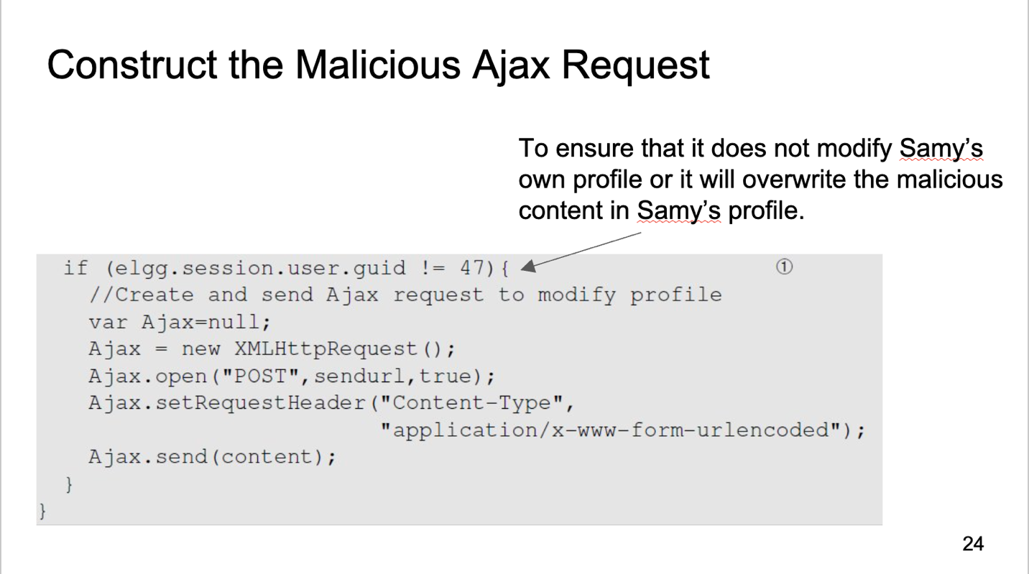
- To ensure it won’t modify his profile himself. If we don’t add this check, after Samy put the code on her profile, it will override this code and attack is failed as the only profile we override was Samy’s.
- We didn't need this check because the add-friend didn't change the js it only made Samy friends with herself
- To defeat XSS attacks, a developer decides to implement filtering on the browser side.
Basically, the developer plans to add JavaScript code on each page, so before data are sent
to the server, it filters out any JavaScript code contained inside the data. Let’s assume that
the filtering logic can be made perfect. Can this approach prevent XSS attacks?
- Yes, since the only way to perform the XSS attacks is put JS malicious code inside victim’s browser. Preventing any malicious JS code from uploading is prevent the malicious code from spreading.
- What are the differences between XSS and CSRF attacks?
 | XSS | CSRF
Exploited vulnerabitity | Failure to properly validate and sanatize user’s input | Exploit a website’s trust with user’s browser by knowingly making a request with the target website with user’s authentic credential
Objective | Stealing user’s information (cookies, session token, personal data), spread malware | Perform unauthorized actions (transfer money, changing user’s data
Storage of malicious data | Stored (Persistent XSS) and not stored (Non-persistent XSS) | Not stored
Impact | User information is stolen, malware is spread | Unauthorized actions are performed
Defend mechanism | Input validation and encoding, output encoding | Use tokens, configure same-site request

- Can the secret token countermeasure be used to defeat XSS attacks?
- No because CSRF tokens isn’t designed to counter XSS attacks, as malicious JS code could do anything user’s website can and can easily find out CSRF token.
- Can the same-site cookie countermeasure for CSRF attacks be used to defeat XSS attacks?
- No because same-site cookie isn’t designed to counter XSS attacks, it was design to configure the request from user is in the same domain website.
- To filter out JavaScript code from user input, can we just look for script tags, and
remove them?
That’s difficult to implement it because there are many more ways to mix JS code with data
- Solution: Use some JS library to validate user’s input: jsoup
- The fundamental cause of XSS vulnerabilities is that HTML allows JavaScript code
to be mixed with data. From the security perspective, mixing code with data is very
dangerous. XSS gives us an example. Please provide two other examples that can be used
to demonstrate that mixing code with data is bad for security.
- SQL injection attacks, Cmd injection
- Why is the CSP (Content Security Policy) effective in defeating the Cross-Site Scripting
attack? What is the downside of this approach?
CSP is effective in defeating XSS because:
- Policy based on the source of the code
Every web page tag a header. CSP parameter will make the rules to see if the web is safe or not.
- Inline code
- Using nonce code to deal with JS code
+ It’s the code was built by the server and it can only use once.
- Using hash code
- Downside of this approach
- Complex set up and deployment, especially for large and dynamic website.
- Potential for false positives: If CSP is not implement correctly, it can block the legitimate scripts and other resources leading to false positives.
- Limited protection scope
- Maintenance overhead
- Browser compatibility
- Can CSP (Content Security Policy) be used to defeat CSRF attacks? Why or why not?

- No because CSP is not design to defeat CSRF, CSP was design to block the execution of malicious JS code from the attacker in XSS
- The following PHP code returns a web page. It also sets the CSP (Content Security
Policy) for the JavaScript code running inside the page. Which JavaScript code is allowed
to execute inside this page.
<?php
$cspheader = "Content-Security-Policy:".
"default-src ’self’;".
"script-src ’self’ ’nonce-1rA2345’ ’example.com’".
"";
header($cspheader);
?>
<html>
<script type="text/javascript" nonce="1rA2345">
... JavaScript Code (1) ... ˚
</script>
<script type="text/javascript" nonce="2rB3333">
... JavaScript Code (2) ...
</script>
<script type="text/javascript">
... JavaScript Code (3) ...
</script>
<script src="script.js"> </script>
<script src="https://example.com/script2.js"> </script>
<button onclick="alert(’hello’)">Click me</button>
</html>

